

Faculty of Engineering Electrical and Computer Engineering Department Real-Time System and Interfacing Techniques Laboratory – ENCS5140 ToDo #1

Prepared by: Aya Dahbour
ID: 1201738

Instructor: Dr. Hanna Bullata
Assistant: Rania Shahwan

Section: 1
October 6, 2024

Front Panel Design

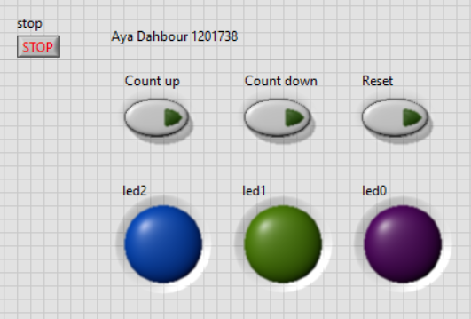
Figure 1: leds off
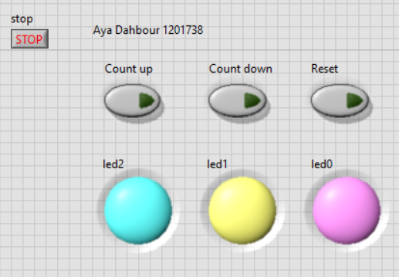
Figure 2: leds on

It contains three buttons a Count Up Button to increment the counter, a Count Down Button to decrement it, and a Reset Button to reset the counter to 0. three LEDs that represent the binary value of the counter, with LED0 as the least significant bit (LSB), LED1 as the middle bit, and LED2 as the most significant bit (MSB). And Stop Button to stop the system.

Block Diagram
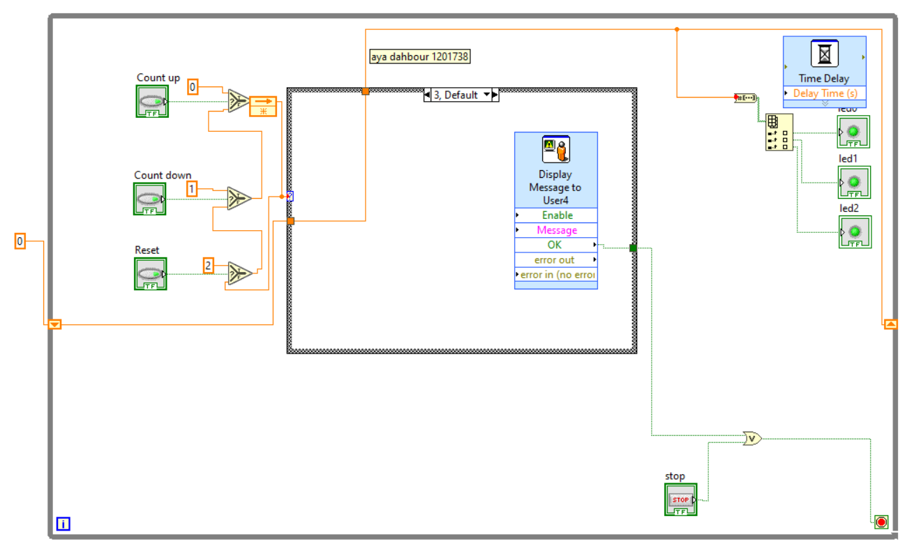

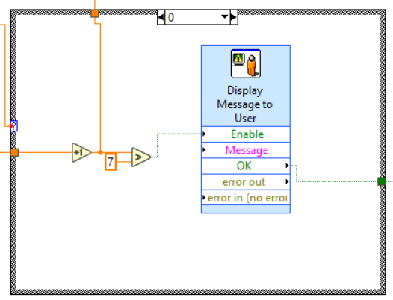
I applied this technique in connection to try to reach the wanted system, so basically, I used the loop to continue the procedure with the condition of stopping it when the button is pressed or when a message is displayed to the user. Using the shift register to keep the value of the variable.
Inside it, I utilized the selector to identify which button is now operating, so that if the value of one of them is true, it returns its own value and it works. The system then selects one of the case structure options based on the provided value. To show the result, the output value was converted from decimal to binary using Number to Boolean Array. The required value was then input with 3 bits into each LED, with a delay to identify the output.
If it is 0, it means count up, so increase the variable by 1 and check if it reaches the maximum.
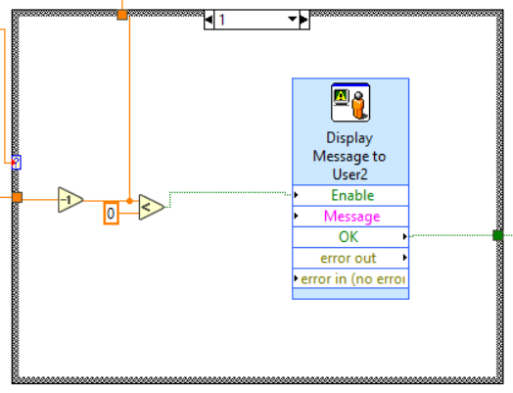
If it is 1, it means count down, so the variable is decreased by 1 and checked if it reaches the minimum.
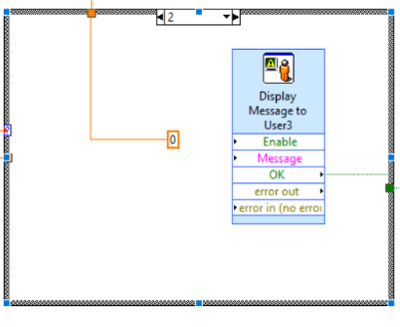
If it is 2, it means reset, so make it equal to zero. Otherwise it is 3, Default mode is empty.

The Output

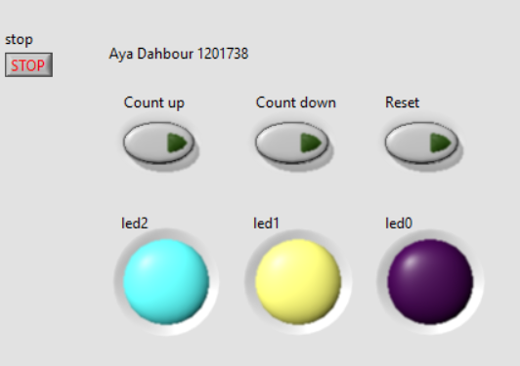
This when it counts up and reach 110 (6).

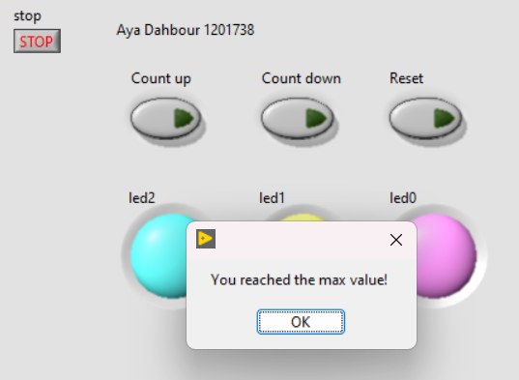
This is 111 (7) which it is the maximum. So, the message displayed.

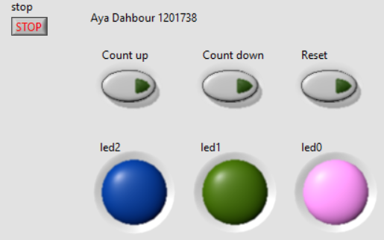
This case after it counts down and reach 001 (1).

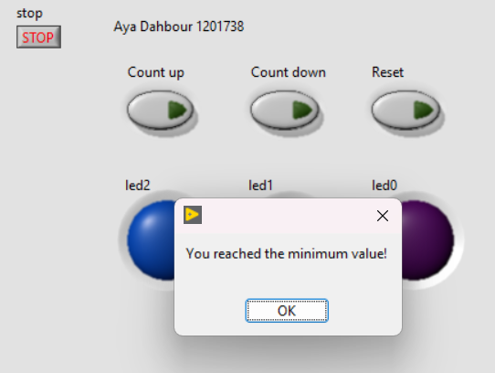
This after it reach 000 (0) which it is the minimum so the message displayed.

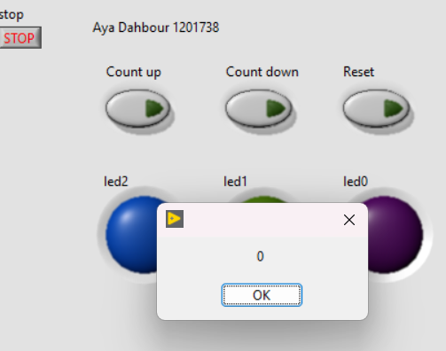
this case when I press “Reset” it return to 0. And I displayed a message to be sure that return 0.

Other cases such as output at each number I can’t list in the report but they are explained in the LabView program file. I tried my best for days to make it work well.

